Staying Healthy to Stop the Coronavirus

During the coronavirus pandemic, it is important for everyone to take good care of their own health so they will stay healthy and they won’t spread the virus to others. I can do my part to keep my self healthy too.
I can wash my hands with soap and water for 20 seconds several times a day. 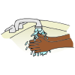
I can play sports by myself or with my family. 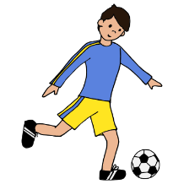

I can do yoga or exercise. 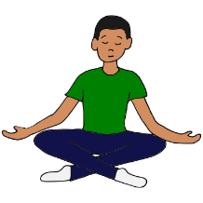

I can get plenty of sleep every night. 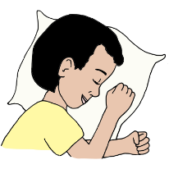

I can eat healthy foods.

I will try to do my best to stay healthy.
